Wind is an AMAZING energy source!
Harness the power of wind.
CLASSROOM COPY
Save Paper, Share in Groups
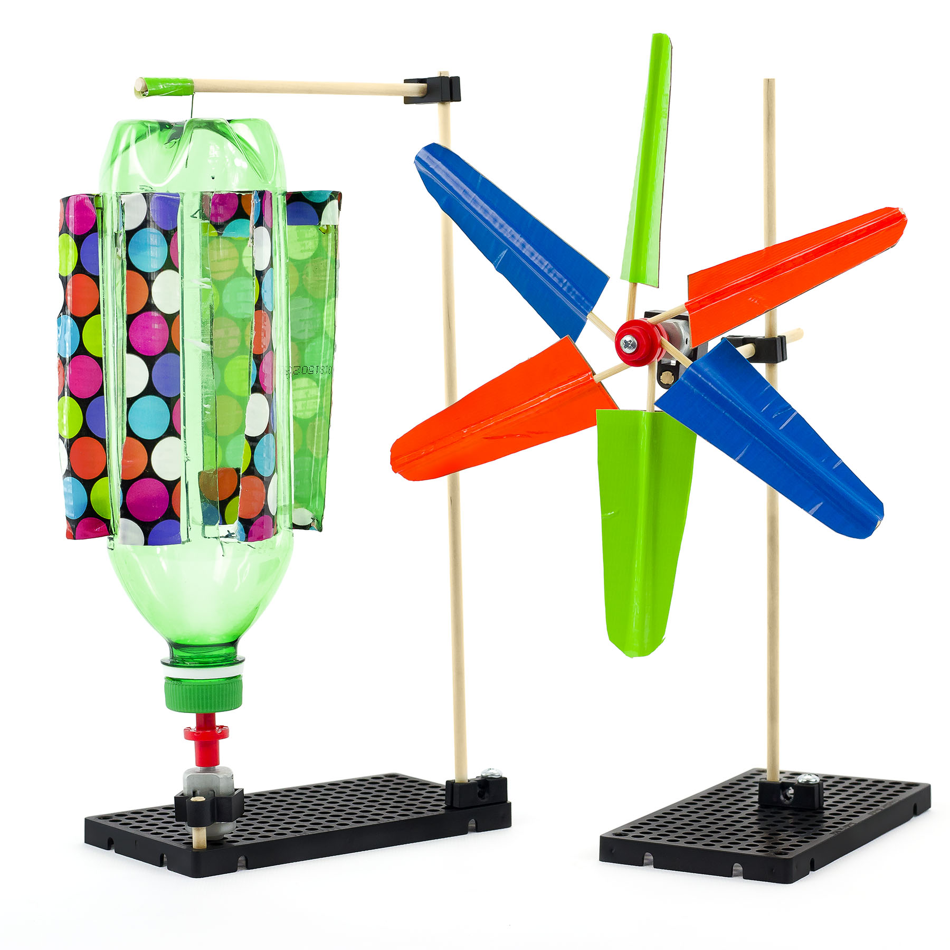
This guide will help you create
your own mini wind turbine.

THINKING AHEAD
What happens when you
change the shape, size
or type of blades?
Download Documents at teachergeek.com
Below is the list of “ingredients” you’ll need for each mini wind turbine.
Available as single: SKU 1823-12 or 10 pack: SKU 1823-13. Both include extra parts for your own innovative creations!
x2 | x2 | x1 | x1 | x1 | x1
Perpendicular Blocks | 300mm (12″) Dowels | Hole Plate | ⅝″ or 1″ #10 Screw | ⅝″ #6 Screw | #10 Nut  Double Check Your Supplies!  This activity needs motor mounts.
x1 | x1 | x10 | x1 | x1
Mini Hub Cover | Mini Hub Base | 150mm (10″) Skewers | 1.5V Motor | Mini Motor Mount
Perfect for sharing in groups of 3 and 4!
Time to break out those tools and start building! Available at teachergeek.com
Multi-Cutter  SKU 1823-81 | Screwdriver  SKU 1823-90 | Pliers  SKU 1823-86

Go on your own scavenger hunt to find these items. Try creating with all kinds of things!
 |  | 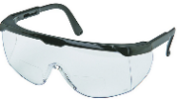
Tape | Recycling Materials (for blades) | Safety Goggles
 | Attach one perpendicular block to the hole plate using a #10 screws and #10 nuts.  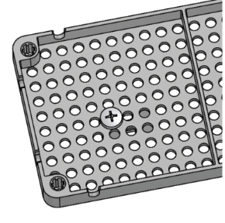  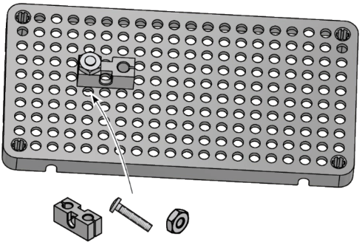 |  | Push a dowel into the perpendicular block to create the turbine tower.  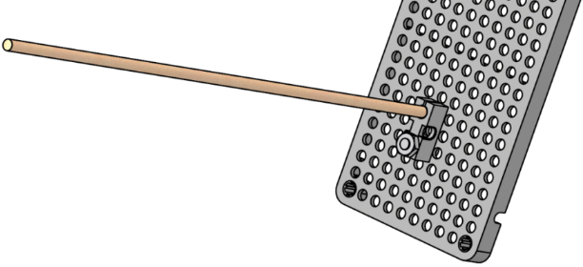
 | Cut a 100mm (4″) dowel and tap a perpendicular block onto the dowel as shown.  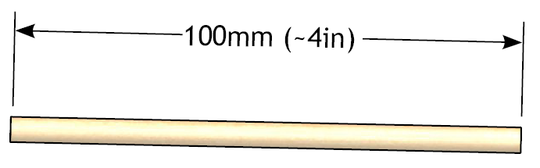  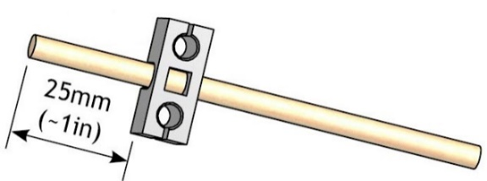 |  | 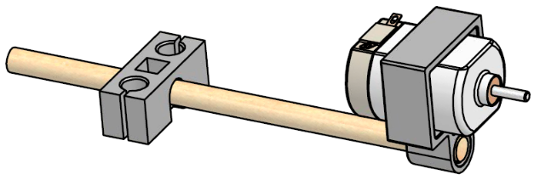  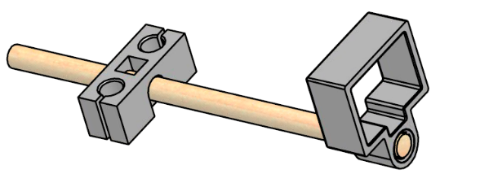  Push the mini motor mount onto the dowel from Step 3 and slide the 1.5V mini motor into the mini motor mount.
 | 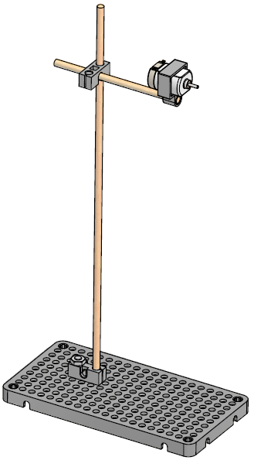  Slide the perpendicular block onto the turbine tower dowel. |  | 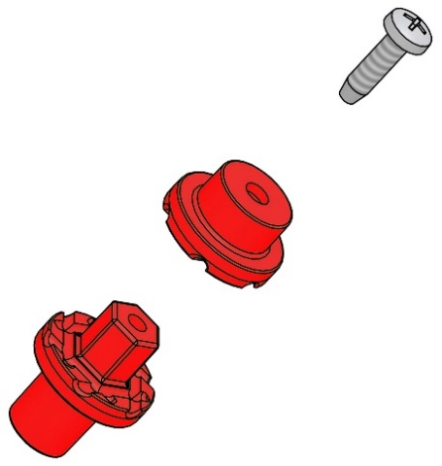  Attach the mini hub cover to the mini hub base using a #6 screw,  but keep the screw slightly loose.  Quick Tip  Hold the base with pliers when loosely turning in the screw.
 | Press the mini hub onto the  1.5V motor shaft.  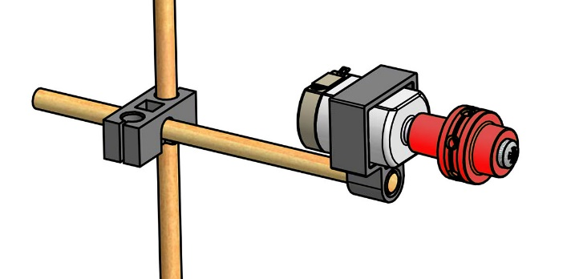 |  | Yea! Your turbine stand is done! Time to make the rotor.  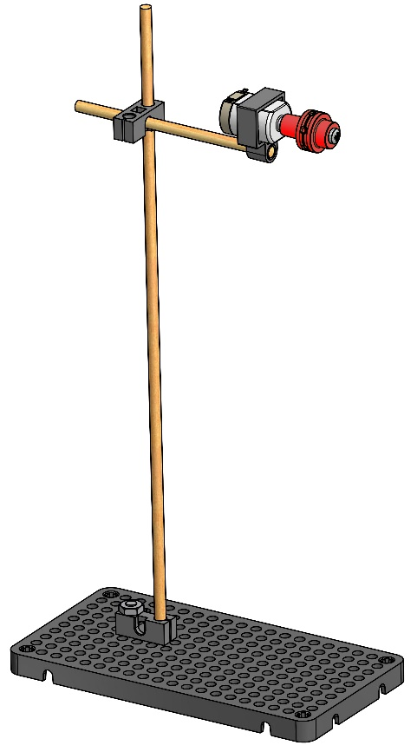

It’s now time to experiment with blade designs. Change the shape, number (between 1 & 6), and the angle of the blades.
 | Cut the points off the skewers.  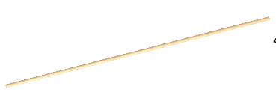  Note: you will only use three of the skewers to start. The others will be for your own design. |  | Find materials for your blades like recycled materials, poster board, card board, plastic, etc.  You will also need tape  (Duct Tape works best).  
Design your blades and start by making 3 blades (below is one method).
Cut a section of blade material.
Place the tape half over the edge of the blade material.

Face sticky side up and place a skewer
at the edge of the blade material, overhanging to one side.
Fold the tape over the skewer to secure to the blade material.
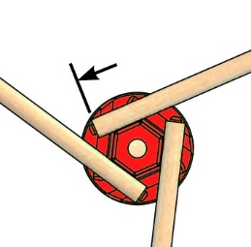
Attach your blades to the hub by
loosening the screw (about a ¼ turn)
to allow the skewer to slide in.
3 or fewer skewers insert all the way into the hub.
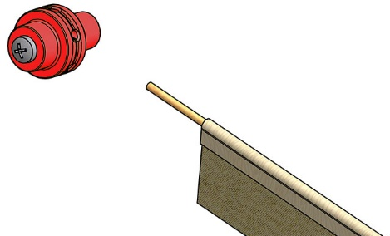
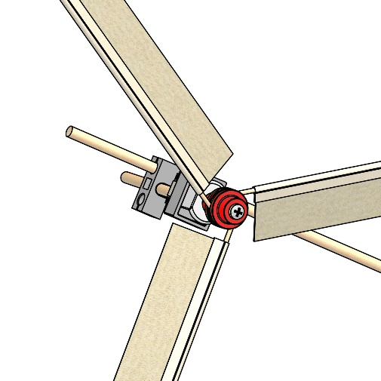
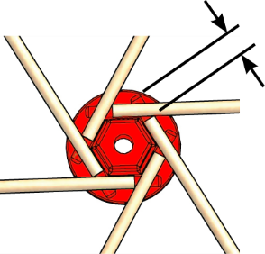

Blades should be
equally spaced in the hub.

Remember:
Re-tighten the screw when blades are properly positioned.

6 skewers can be inserted as shown.

- How can you change the blade design to spin faster?

- Would smaller blades increase power produced?

- How would a different blade material or type work?
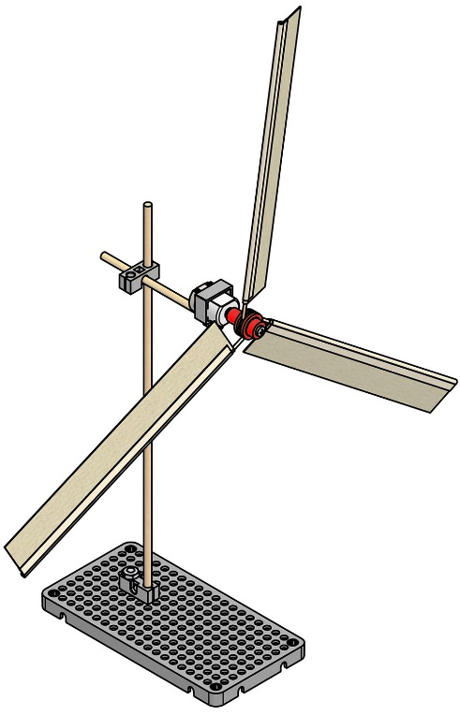
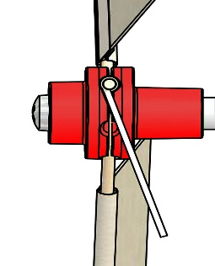
a
Congratulations!
Now try your design in the lab.
angle
Change your blades pitch when screw
is loosened.

