Name: ______________________________________________ Set: _______________
Engineer a mini wind turbine with the greatest output.
Criteria:
- Only components from the TeacherGeek Mini Turbine kit may be used, as well as approved blade materials.
  - Blades may not be:
    - Premanufactured (purchased in the shape they are used)
    - Dangerous
    - Metal
    - Sharp Edged
- Safety glasses must be worn when testing wind turbines.
- Turbine must be tested 50cm (20in) from the teacher provided fan. Fan speed, angle and direction may not be modified.
Engineering Process:
The engineering process will be used to evolve your wind turbine through revisions (design changes). Scientific testing will provide data to engineer the ultimate turbine.
- Design:
  - Research: Analyze your current design and test data.
Explore science that makes it work. Study existing
designs and concepts.
  - Identify a Problem: Use your Research to identify an
area where your turbine can be improved.
  - Generate Possible Solutions: Come up with creative
ideas that could solve the problem.
  - Choose the Best Solution: Select the solution you believe
will best solve the problem.
  - Plan: Create drawings, identify materials & processes required to construct the solution.
- Construct: Create the mini turbine, or turbine revision according to your design plan.
- Test & Evaluate: Evaluate the wind turbine and solution. Did your last revision work well? What can be improved? No design is perfect. Your wind turbine can always be improved.
- Repeat (Redesign): Engineer a solution to the problem(s) identified in the evaluation. Create a new revision.
Don’t worry about having a design “flop”. Spectacular design revisions often follow “flopped”
designs (you can learn a lot from a “flop”). Challenge yourself to create unique designs.

- Redesign your basic wind turbine using an Engineering Note page:
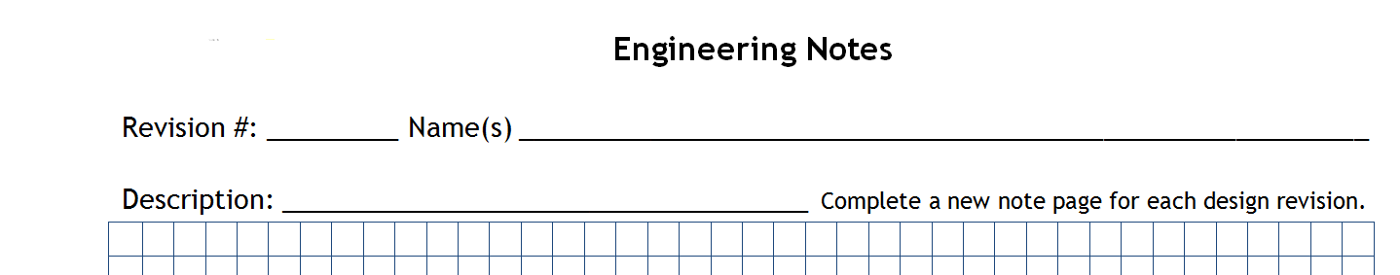
1 Wind eaters
6 Blade Design

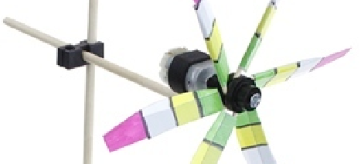
- Construct the new design.

- Test the design. Record your test data in the test record, and on the engineering note page:
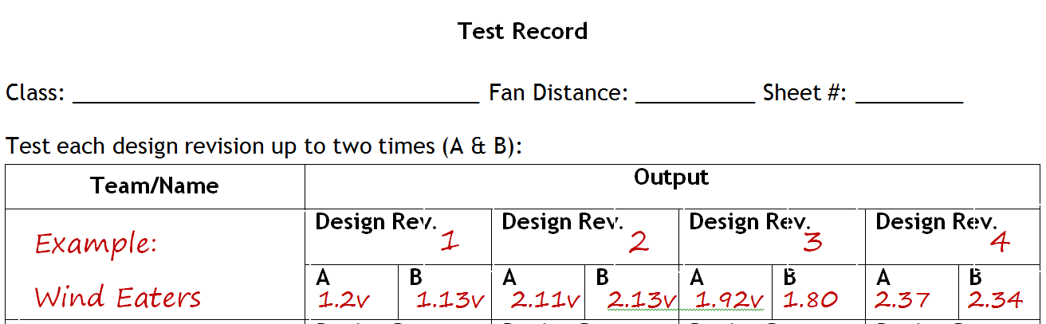
1M 1
Science 8

- Evaluate the design based upon test performance, observations and research:
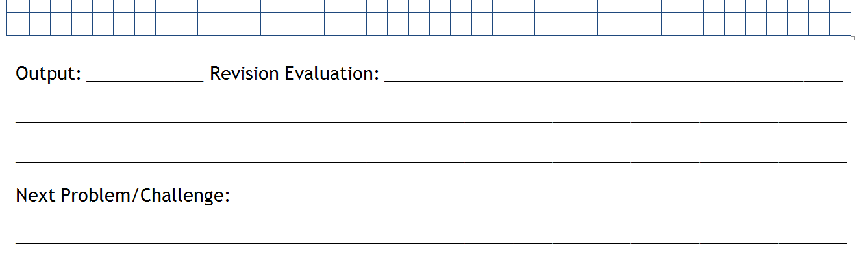
1.2v Not great. A blade broke
during testing. We need a new blade material.
Broken Blade: Redesign with a stronger material

- Redesign (create a revision) to overcome the problem(s) identified by the evaluation.
1 Wind eaters
3 Blade Design
- Redesign, Repeat.

Name: ___________________________________________________________
Set: _______________ Date: _______________
Criteria: 10pts
How well does the turbine fit the competition criteria?

Use of Time: 15pts
How much productive time did you spend working on the challenge? Did you work until the time ran out?
Did you work extra hours (for bonus points)? Regular Points= 0-15. Bonus Points= 16-18.

Revisions: 15pts
What was the quantity and quality of your design revisions?

Innovation: 20pts
How unique and creative was your design and revisions? Regular Points= 0-20. Bonus Points= 21-15.

Performance: 15pts
How did your turbine output compare to the output of other turbines in your class? Higher Output = More points.

Documentation: 15pts
Did you carefully document the engineering process using note sheets?

Spirit: 10pts
Did you demonstrate energy and enthusiasm for the project? Were you cooperative and helpful to your teammates and competitors?
Student Provided Score (Self-Score):
Teacher Provided Score:

Test Record

Class: __________________________________ Fan Distance: __________ Sheet #: _________
Test each design revision up to two times (A & B):
Team/Name | Output
 | Design Rev. |  | Design Rev. |  | Design Rev. |  | Design Rev.
 | A | B | A | B | A | B | A | B
 | Design Rev. |  | Design Rev. |  | Design Rev. |  | Design Rev.
 | A | B | A | B | A | B | A | B
 | Design Rev. |  | Design Rev. |  | Design Rev. |  | Design Rev.
 | A | B | A | B | A | B | A | B
 | Design Rev. |  | Design Rev. |  | Design Rev. |  | Design Rev.
 | A | B | A | B | A | B | A | B
 | Design Rev. |  | Design Rev. |  | Design Rev. |  | Design Rev.
 | A | B | A | B | A | B | A | B
 | Design Rev. |  | Design Rev. |  | Design Rev. |  | Design Rev.
 | A | B | A | B | A | B | A | B

Engineering Notes
Revision #: _________ Name(s) __________________________________________________________
Description: ________________________________________ Complete a new note page for each design revision.

Output: ______________ Revision Evaluation: ________________________________________________________
__________________________________________________________________________________________________
__________________________________________________________________________________________________
Next Problem/Challenge:
__________________________________________________________________________________________________

