**What will you need from the Spring Scale Pack?**

|  |  |  |  |  |  |
| --- | --- | --- | --- | --- | --- |
|  |  |  |  |  |  |
| **1 Connector Strip** | **2 Dowels** | **1 wire** | **1 Pin** | **1 Rubber Band** | **2 Slide Stop 6mm (1/4in) Sections** |

**Suggested Additional Materials:** Paper Clip, Tape, Heavyweight Paper

**Required TeacherGeek Tools:** Reamer, Cutter**. Optional Tools:** Pliers, Hammer

Safety Glasses should be used when cutting

**Build Instructions:**

**1.** Cut two 7-hole connector strip sections. Save the extra section.

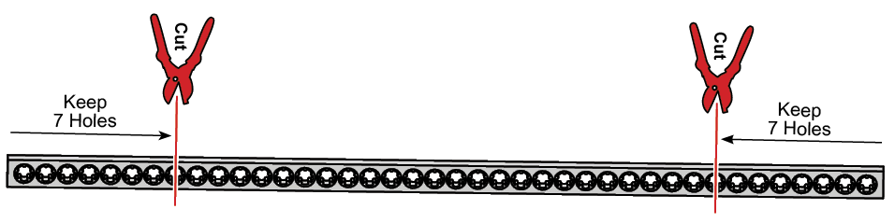

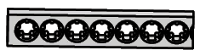

**2.** Cut a 300mm (12in) dowel in half to get two 150mm (6in) dowels.

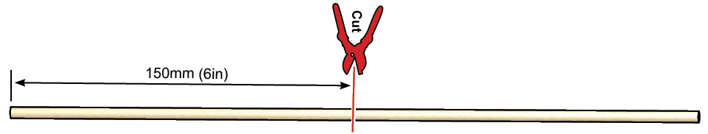



|  |  |
| --- | --- |
| **3.** Tap or wiggle the 150mm (6in)  dowels into a 7 hole strip. | **4.** Tap or wiggle a 7 hole  strip onto the dowels. You  just made the frame! |

**5.** Cut two 6mm (1/4in) sections of slide stop (if they have not already been cut).

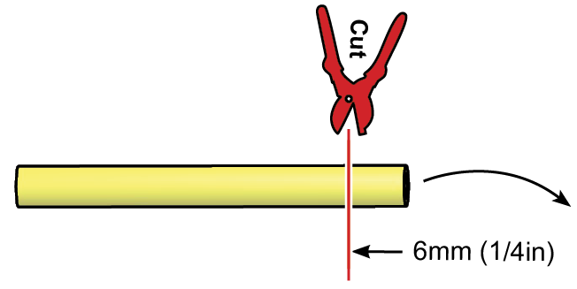 

**6.** Place one slide stop section onto an uncut (300mm, 12in) dowel.



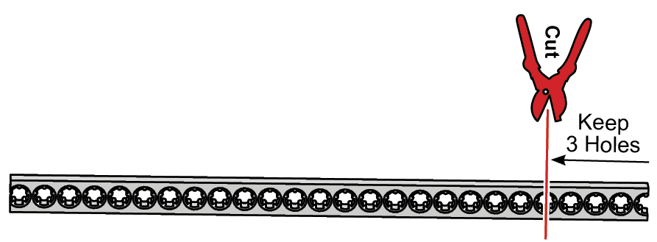**7.** Cut a strip with 3 holes.

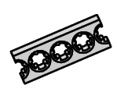

**8.** Cut a rubber band to make it straight.

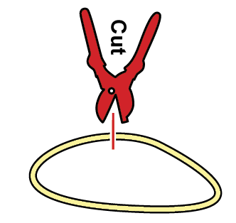 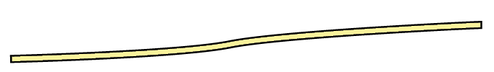

**9.** Place the end of the cut rubber band through the center hole in the strip. Tap or wiggle the strip onto the dowel from Step 6.You just made the spring scale piston!

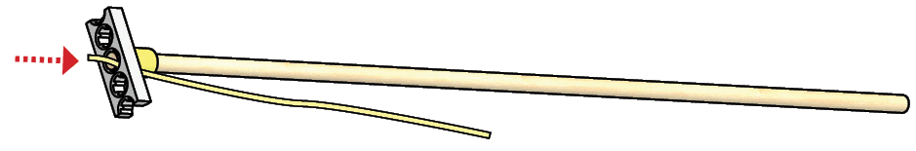

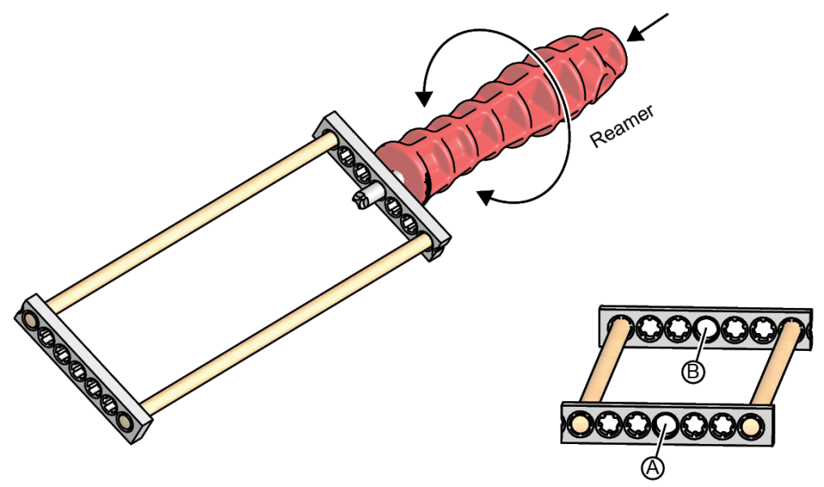**10.** Ream holes (A) and (B) in the frame you finished during Step 4. Turn the reamer as you push it through the holes. Note: These are the only holes you should ream on your spring scale.

**11.** Slide the spring scale piston through the reamed frame holes. The piston should slide in easily (if not, ream the frame holes more). Then place slide stop on the end of the piston.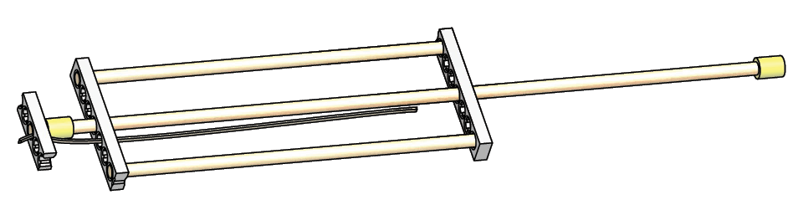

**12.** Cut loose a single pin (if it has not already been cut loose).

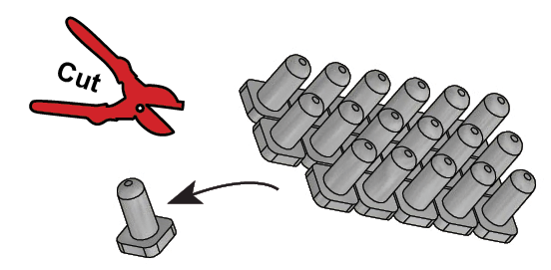

**13.** Stretch the rubber band through the frame holes. Place a pin in the last hole to keep the rubber band from slipping out.

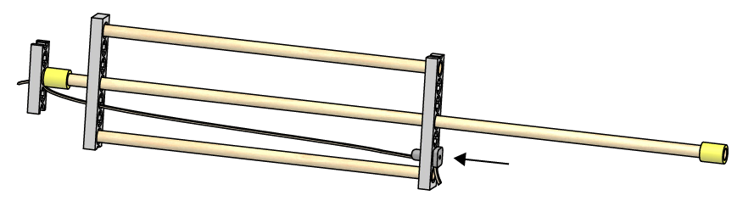

**14.** Bend a wire or paper clip into a hook shape and attach it to the plunger. The included wire is strong, but paper clips are easier to bend.

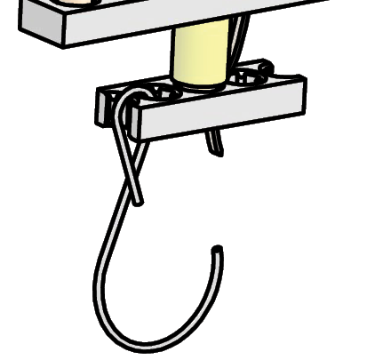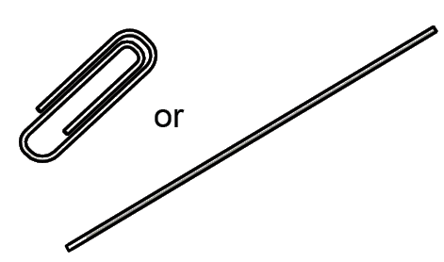

**15.** Now you need to place graduations on your spring scale to measure how far the plunger moves. Graduations (C) can be placed on paper (A) and taped to the frame. Make sure your place a mark (D) on the plunger so you can measure how far it travels across your graduations.

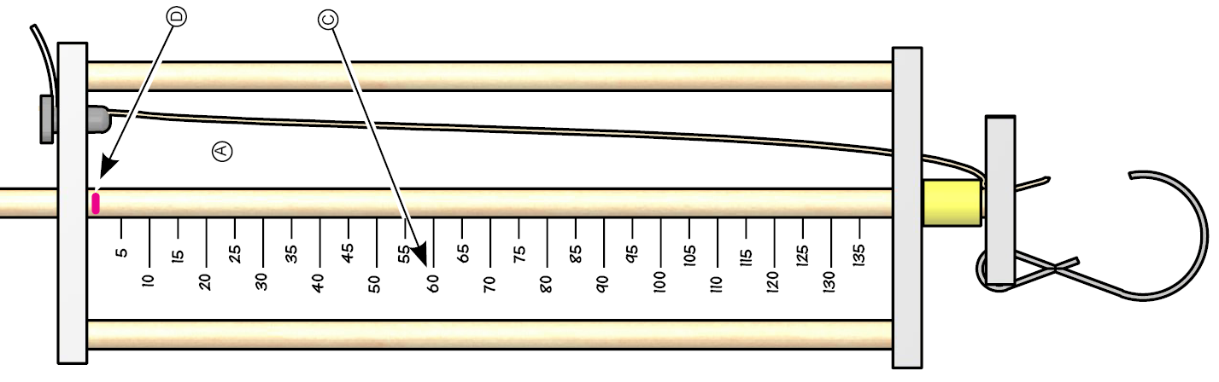

The spring scale can be used in multiple ways:

Hanging Platform



