This guide will show you how to assemble, fill, and connect TeacherGeek cylinders. TeacherGeek cylinders are not for medical use or food contact.

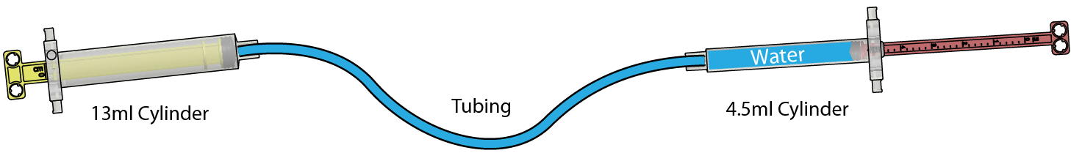

Cylinder Construction
Repeat steps 1-5 below to create your cylinders. The steps show construction of a 13ml cylinder, but same steps can be used to create the 3.5ml cylinder.
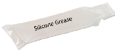
Caution: Do not assemble your cylinders without silicone grease. The plunger will stick and fail without silicone grease lubricant.

Step #1
Gather your components. You will also need one silicone grease packet.
Components to create one 4.5ml cylinder:
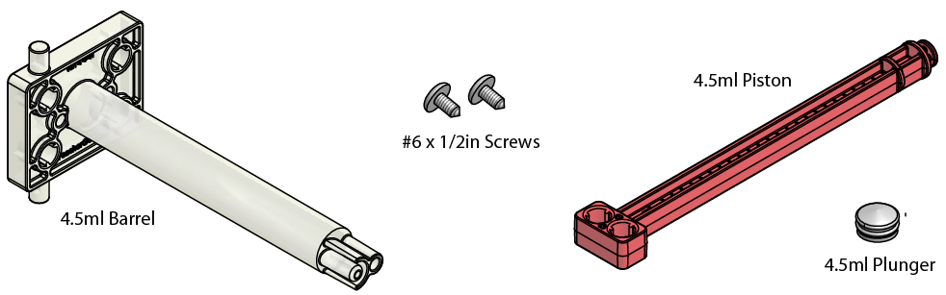
Components to create one 13ml cylinder:
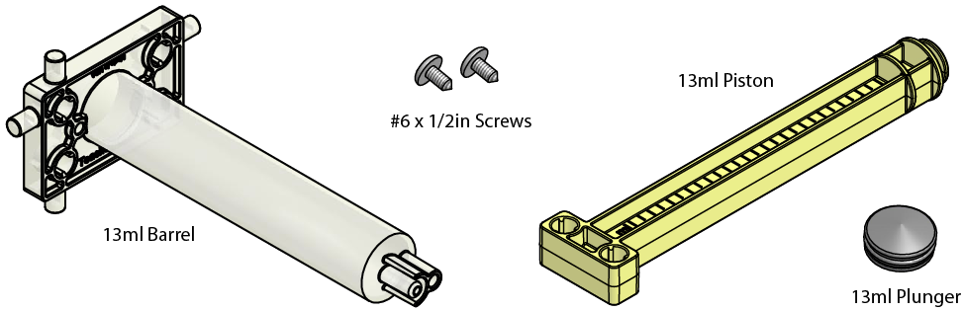
Step #2
Place the plunger onto the piston.
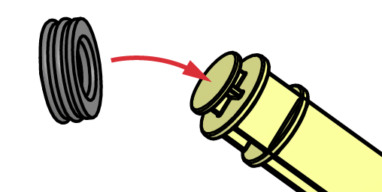
Step #3
Apply a small amount of silicone grease (best) or vegetable oil around plunger.
Note: Do not use Petroleum lubricants. They will cause the plunger to stick and fail.
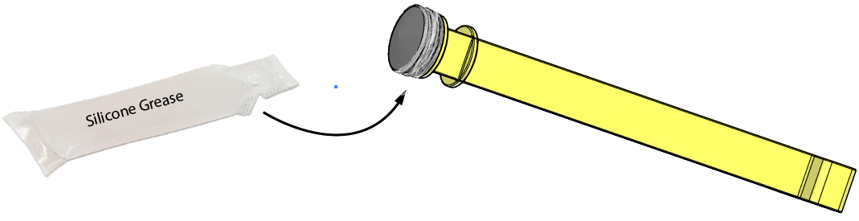
A small amount of silicone grease will lubricate many plungers. One packet can lubricate over 30 pistons. Save the extra lubricant to use later.

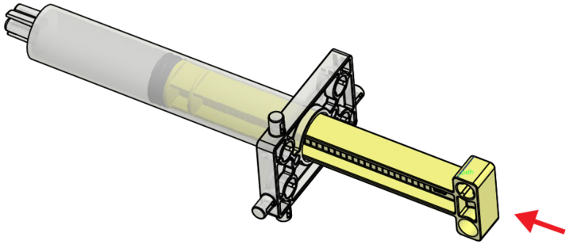
Step #4
- Make sure the plunger is lubricated to keep the plunger from sticking in the barrel.
- Insert the piston assembly into the barrel. Move the piston in and out to lubricate the barrel.

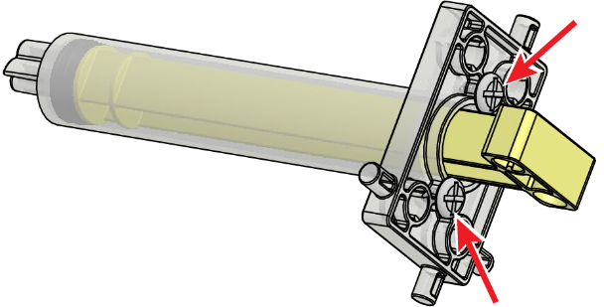
Step #5
Turn two #6 screws into the barrel to keep the piston from coming out.

Repeat steps 1-5 to create your cylinders.
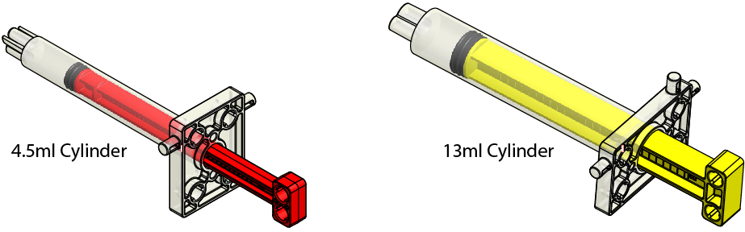

Hydraulic System Assembly

The following steps show you how to connect cylinders to create a hydraulic (liquid filled) system.

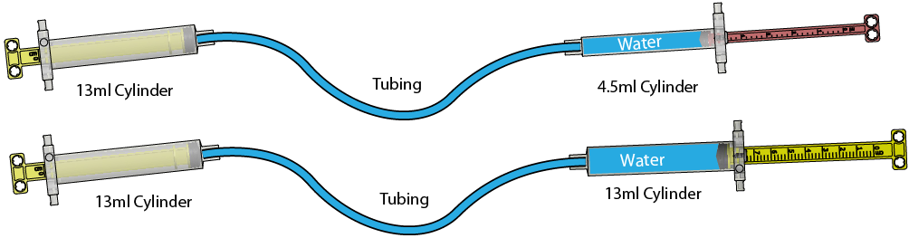

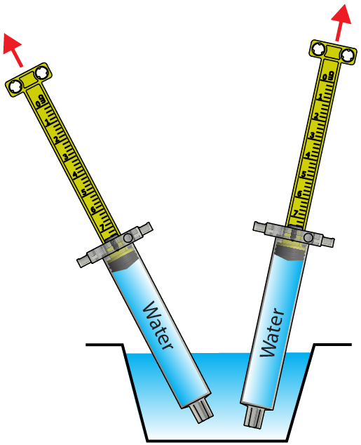
Step #1
Fill each cylinder with water:
- Push the cylinder pistons in.
- Place the cylinder tip under water.
- Pull the piston back to completely fill the cylinder with water.
Note: There should be no air bubbles in the water filled cylinders.
Tip: Color the water.

Step #2
Attach tubing to the first water filled cylinder. If you will be connecting a 13ml and a 4.5ml cylinder with tubing, attach the 13ml cylinder to the tubing first.
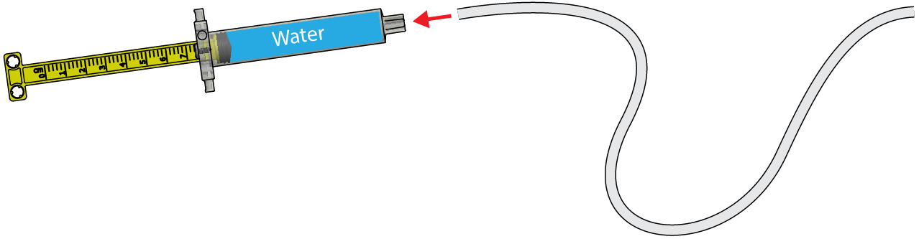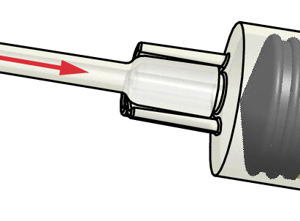
Step #3
Push in the cylinder piston completely to fill the tubing with water. The cylinder and tubing should have no air in them.

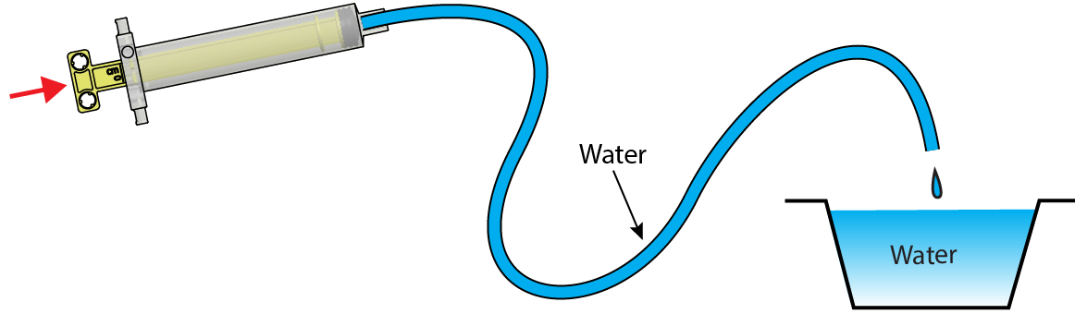
Step #4
Attach the water filled tubing to the second water filled cylinder. Your hydraulic system is finished.
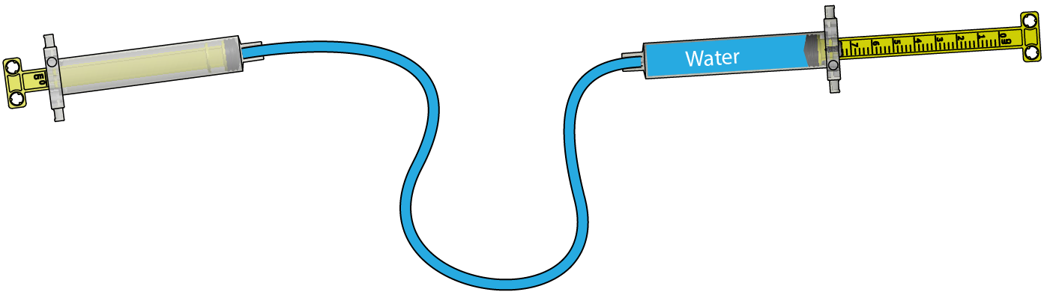

Step #5
Insert a screw into the hole aside the cylinder tips to keep the tubing from pulling off.
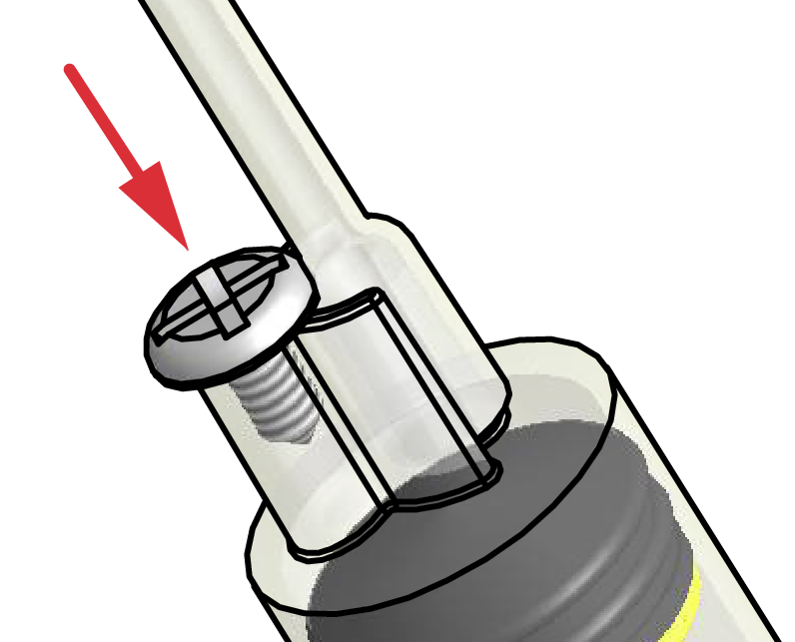
Have you repeated steps 1-5 to create the hydraulic systems you need?
If so, continue.

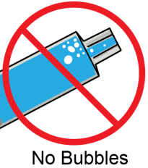
Your hydraulic system will not work well if air is in the cylinders or tubes. You will periodically have to remove tubing from a cylinder to bleed the lines (remove air from the lines), and refill the lines.

Pneumatic System Assembly

To create a pneumatic (gas) filled system, follow the steps above, but with gas instead of water. Most pneumatic systems use air.
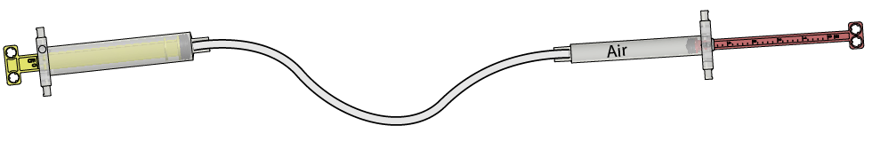
Cylinder Increments

Cylinder pistons are marked to show the distance they are pulled out (cm), and the volume inside the cylinder (ml).
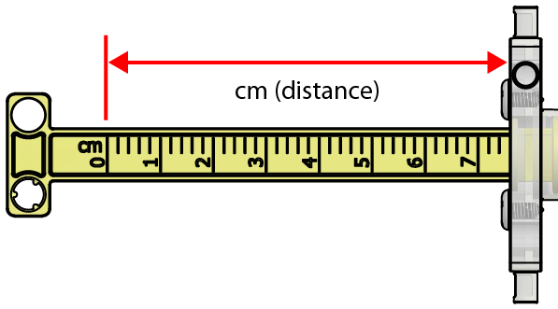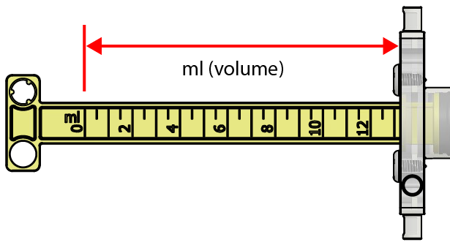
Other Fluid Components

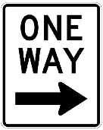
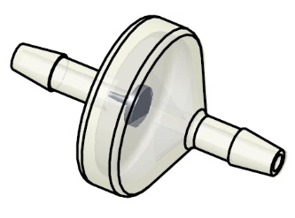
Check Valve
Check valves allow a fluid to pass in only one direction.

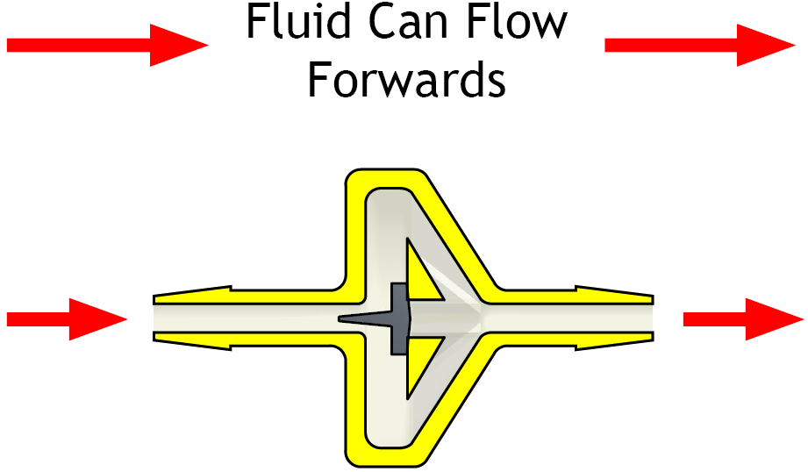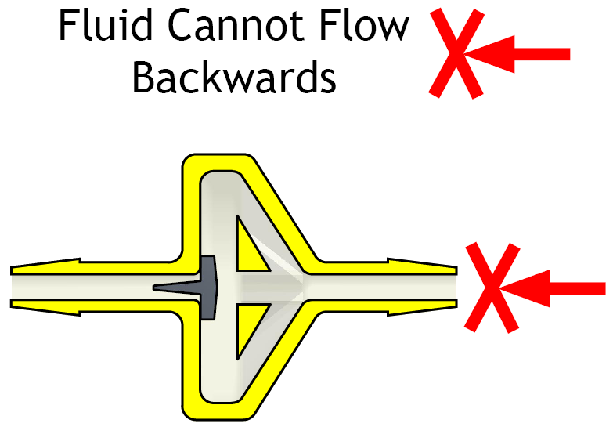
Tee
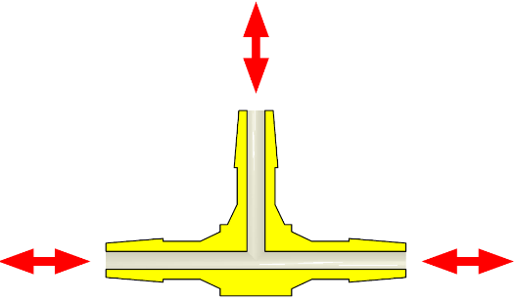
A tee connects three tubes, and allows fluid to pass between them.
