This guide will take you through the process of creating an example yeast mobile.
Customize your student’s engineering experience; the word version can be edited to fit your classroom, where you can choose to provide students with some or all of the instructions.
Race your yeast mobiles when they are done. Challenges: Distance, Speed (first to travel 2ft).
How does the example yeast mobile work?
Note: this is an example. Students yeast mobiles should incorporate unique design solutions.

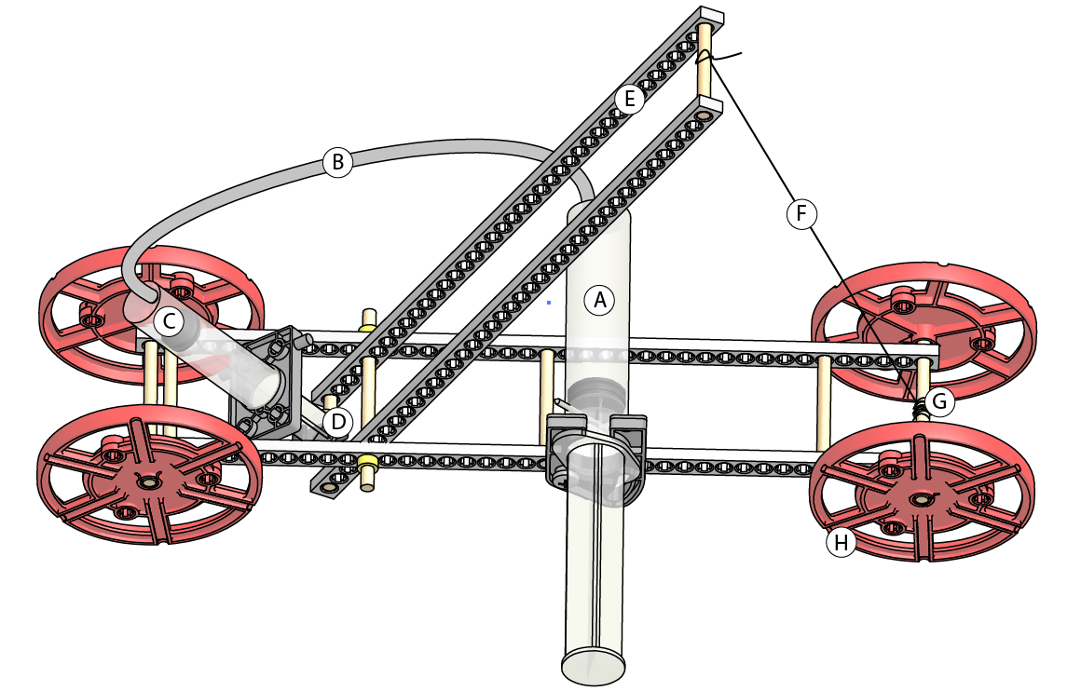
- Pressure is created by the production of gas in chamber A
- Pressure transfers to chamber C through line B (Pascal’s law)
- Pressure in chamber C forces piston D down
- Lever Arm E trades force generated by piston D for Distance (pulling string F)
- String F wraps around Axle G, so when string F is pulled it unravels the and turns axle G.
- Axle G is connected to the wheels (H). The wheels turn when Axle G turns.

Concepts:
Simple Machines
Build Instructions:
Step 1: Cut Three 55mm (2 1/8in) dowels.
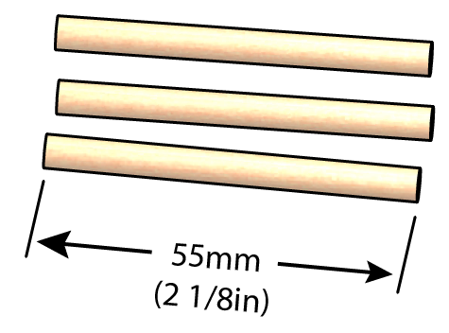
Step 2: Push or tap the dowels into a full connector strip as shown.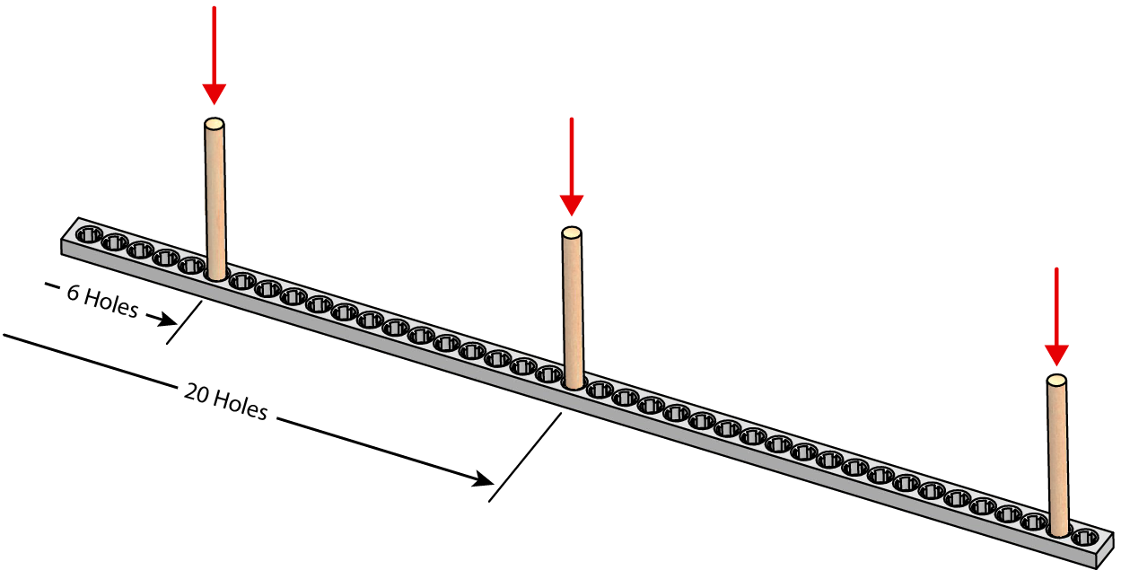
It should look like this when you are done:
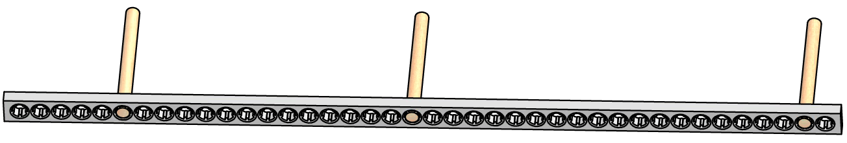
Step 3: Place a second connector strip on to the assembly from Step 2 as shown.
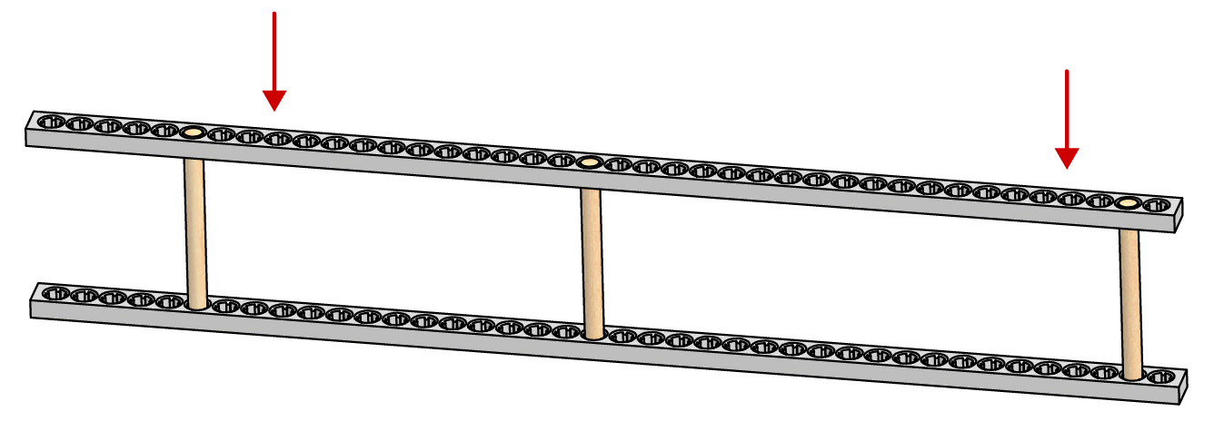
Step 4: Ream holes marked A, B, C and D below.
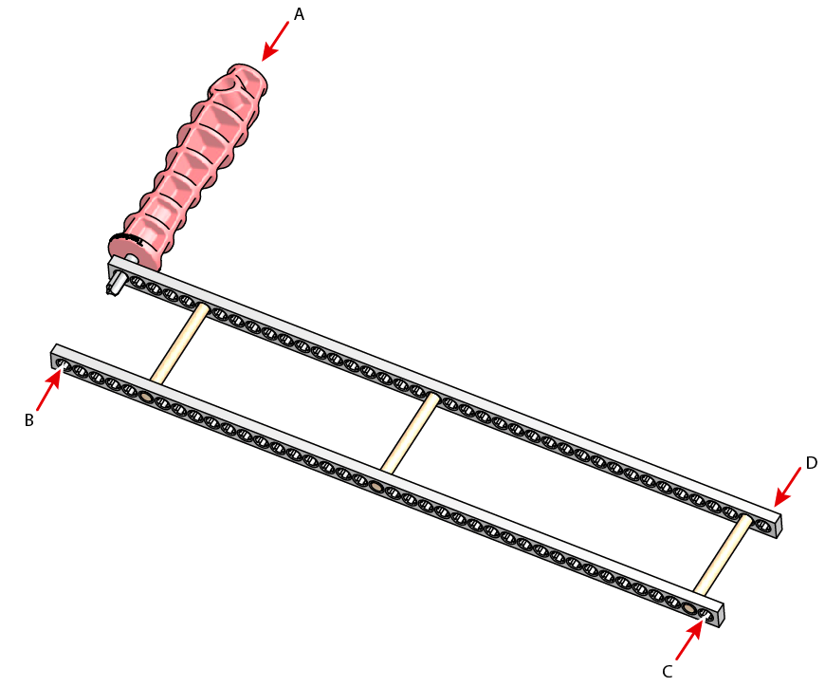

Step 4: Cut two 80mm (3 /1/8in) dowels

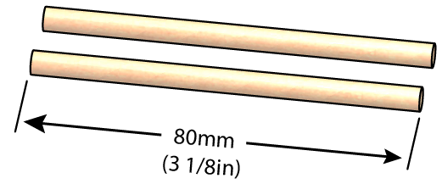
Step 5: Push/tap the dowels from Step 4 into wheels.
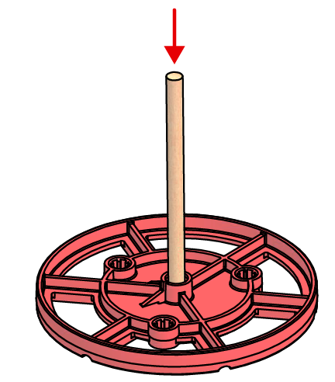
Step 6: Insert the wheel assemblies from Step 5 into the frame from Step 4.

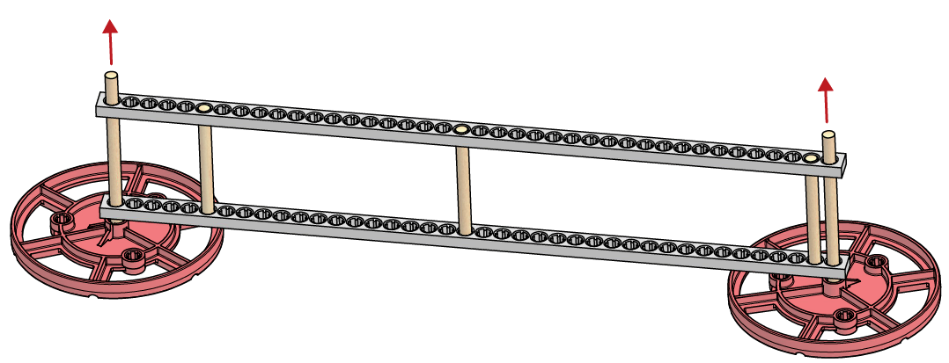
Step 7: Push/tap two more wheels onto the wheel assemblies from Step 4.
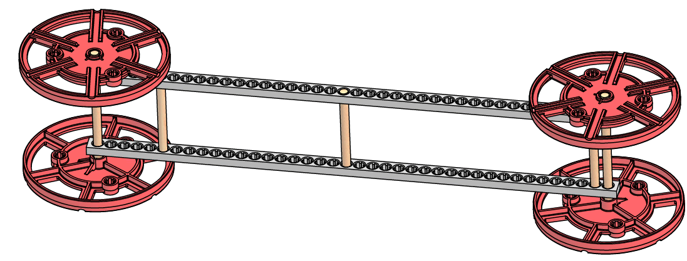
Step 8: Give it a roll. Make sure your yeast mobile frame is working properly, and that it will roll with the least resistance. Examine: Friction, Alignment
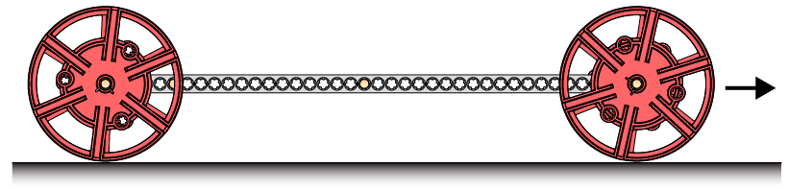
Step 9: Cut two 45mm (2 3/4in) dowels.
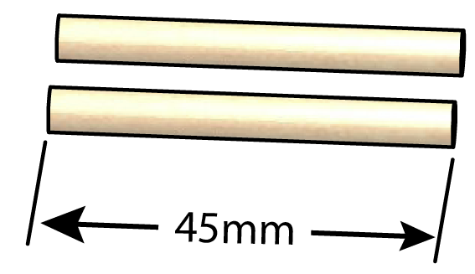

Step 10: Push/tap the dowels from Step 9 into a new full connector strip.
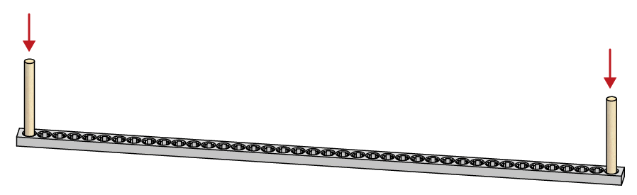
Step 11: Push/tap a new full connector strip onto the dowels from Step 10.
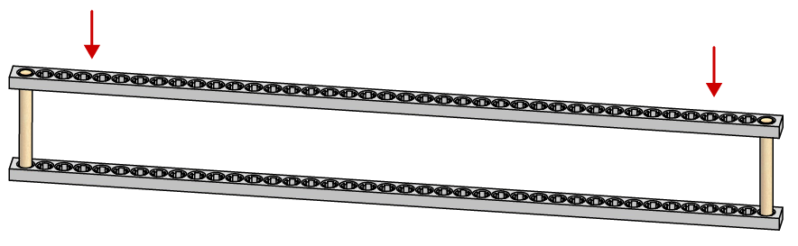

Step 12: Ream holes A, B, C, and D in the frame and arm assembly created in Step 11. The reamed holes will become a pivot point (fulcrum) for the lever arm.

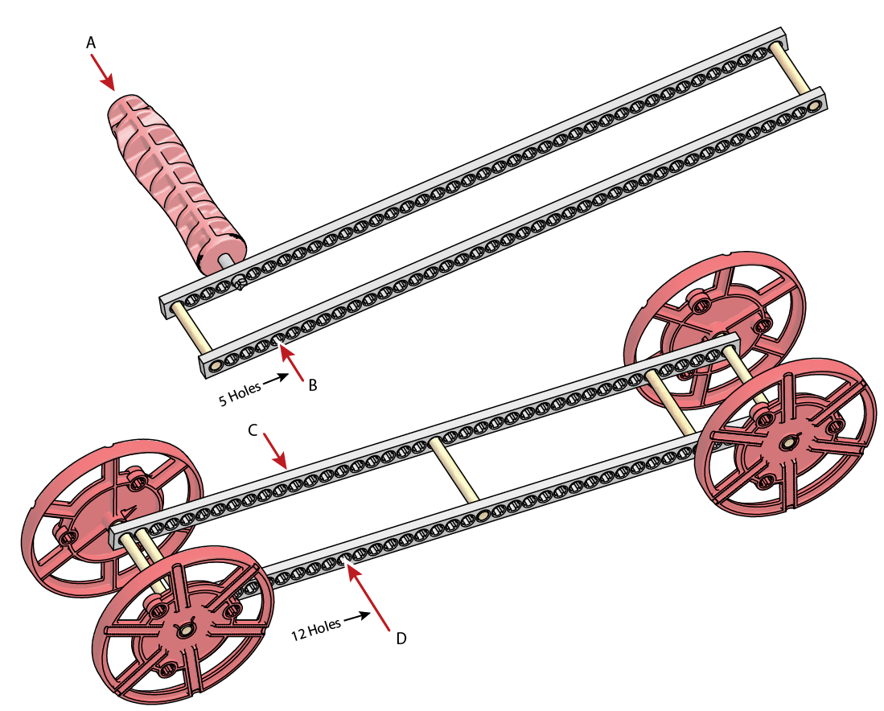
Step 13: Cut one 80mm (3 1/8in) dowel.
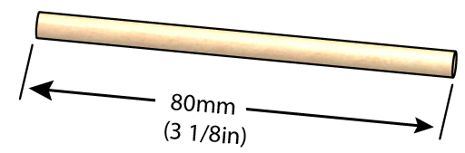

Step 14: Slide the dowel from Step 13 though the holes reamed in Step 12.

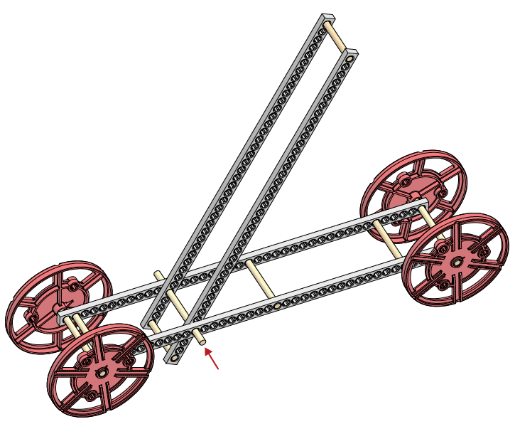
Step 15: Cut two 3mm (1/8in) sections of slide stop.
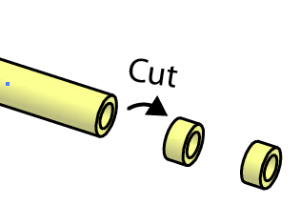
Step 16: Secure the loose dowel with slide stop sections from Step 15.
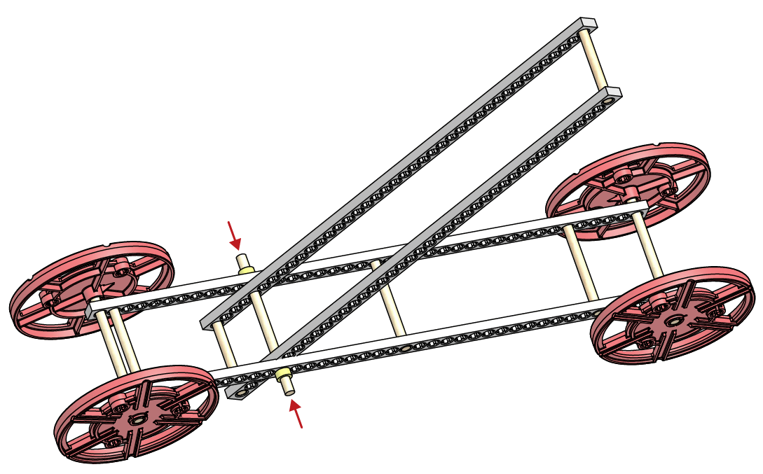
Step 17: Assemble the 10cc the cylinder as shown.

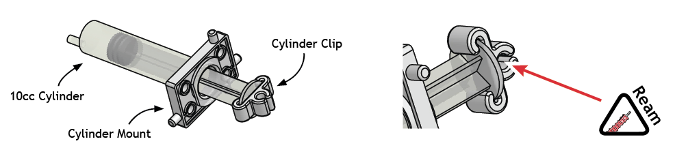

Step 18: Attach the cylinder assembly from Step 17 to the frame and arm.
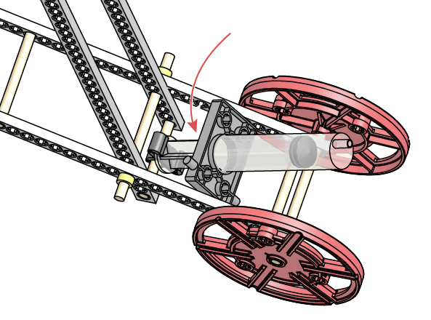
Step 19: Use a 150mm (12in) section of tubing to connect the 10cc cylinder to the 30cc cylinder. Experiment: Move the cylinders and lever arm. Discover the mechanical advantages.
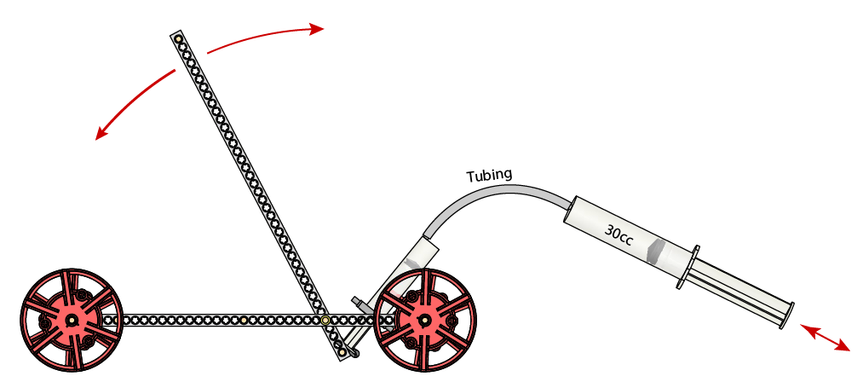
Step 20: Attach a string (not supplied) to the lever and wheel axle. The string should be long enough so that it continues to unwind as the lever arm moves away from the axle.
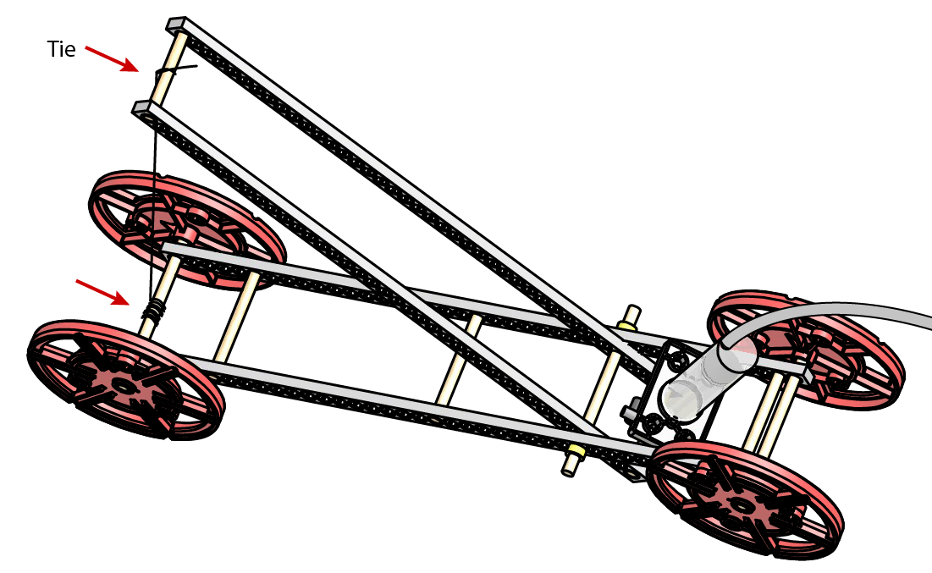
Step 21: Attach the 30cc cylinder to the frame using a mount, screw and nut.
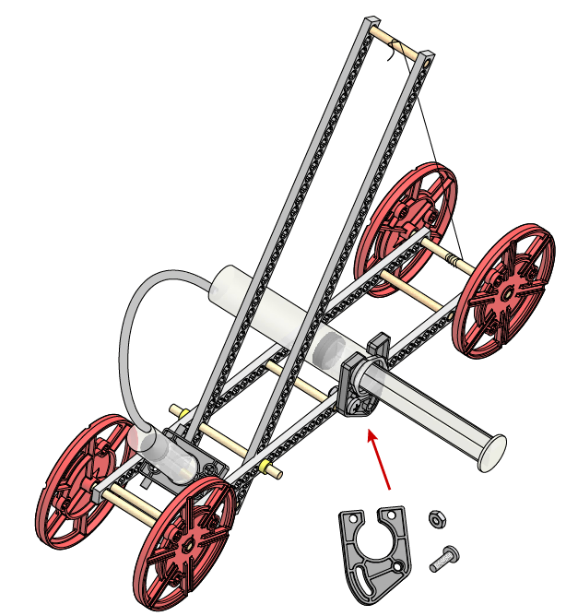
How will it work?
Wind the string up on the axle, pulling the lever arm down. Remove the piston from the 30cc cylinder. Add a yeast, or other gas producing solution. Quickly replace the piston. The expanding gas should transfer to the 10cc cylinder and cause it’s piston to push outward.

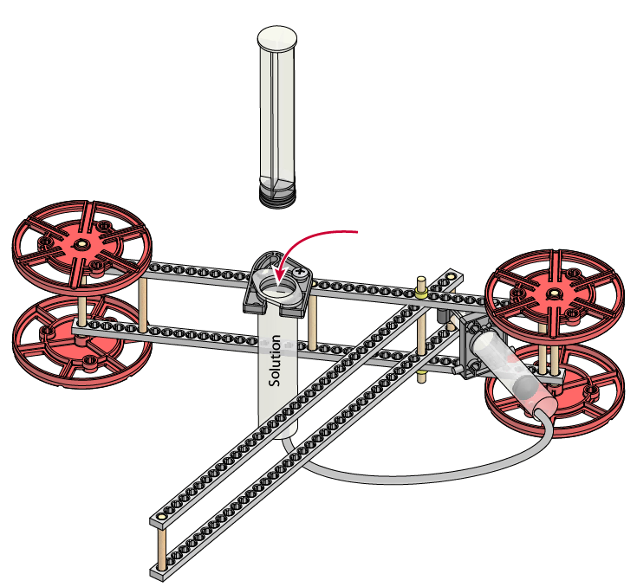

Problem: The 30cc piston will want to pop out from pressure inside the cylinder. Solution: Find a way to secure the piston so it cannot pop out. The picture below shows a nail placed through a hole to secure the piston.
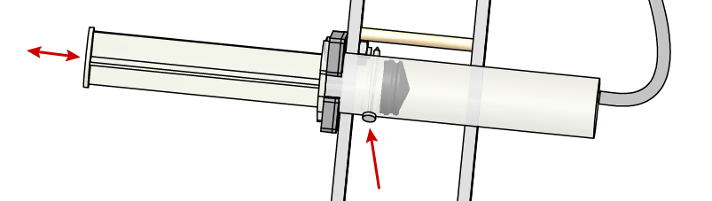
Engineer: Now it’s time to test, modify and improve your yeast mobile. You have constructed the example design, but it is not the best design or configuration. Ideas: Experiment with mechanical advantage by changing where the piston and string attach on the lever. Create a new frame configuration. Develop the ideal yeast solution (food, water, temperature) through scientific method.

